Use Case Realisation Report - Manage ProjectRaise Interest
FOR
Volunteer Management System
(VMS)

CLIENT
PROJECT | Volunteer Management System (VMS)
TITLE | Use Case Realisation Report - Manage ProjectRaise Interest
VERSION | 0.1a
DATE | 13-Aug-2011
 | ORIGINATOR
 | Name / Signature | Team 8S
 | APPROVAL
 | Name / Signature | Phung Kim Cuong, Dio
Institute of Systems Science |  | Document Reference
25 Heng Mui Keng Terrence  Singapore 119615 |  | VMS/PM-1.3.1/1

 | Acceptance
 | Customer Signature |  | Customer Signature
 | Name & Designation |  | Name & Designation
 | Date & Company Stamp |  | Date & Company Stamp

Revision History

Date | Version | Description | Author
12-Jun-2011 | 0.1a | Creation | Team 8S
 |  | Refer to amendment history

Table of Contents

1. Brief Description 3
2. Flow of Events 3
2.1 Standard Flow 3
2.2 Exceptions 3
3. Interaction Diagrams 4
3.1 Domain Collaboration Diagram: Raise Interest 4
4. Participating Objects 4
5. Derived Requirements 4
6. Derived Requirements 4
ANNEX D Amendment History 4

Use-Case Realization Report
Raise Interest

Brief Description
The use case enables registered user to propose new project.

Flow of Events
The standard flow of events for this use case and any exceptions are described in the following subsections. See section 3.1 for an overview of the participating Actors and Domain Objects.

Standard Flow

Precondition: Volunteer has logged in the system and use case 4.6 has been executed

This use case provides the user interface related functionality that will be provided to the User, as follows:
- When the Volunteer clicks ‘raise Interest’ button on the ProjectDeatilsScreen, the ProjectDeatilsScreen .raiseInterest() method is triggered.
- ProjectDeatilsScreen.raiseInterest() uses the method ProjectController .addProjectInterest() to create a new project membership request.
- ProjectController will first fetch the projected from the Project Object by using method Project.getprojectId()
- Then ProjectController will use the ProjectInterest .create() method of ProjectInterest object to create an new instance with the volunteer userName and projected
- Finally, the ProjectController will use ProjectDetailsScreen.displayMsg() to notify the volunteer that a new request has been sent for Project Manager review.
- The use case terminates

Exceptions
The following exceptions have been identified:
- Invalid Information Format. If any of input info is incompatible, system will give a validation summary for user to make corrections

Interaction Diagrams

Domain Collaboration Diagram: Raise Interest
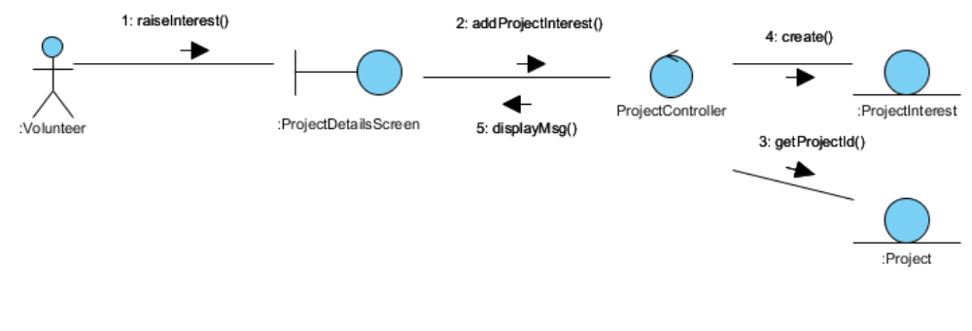

Participating Objects

Volunteer

This entity object stores the details concerning a volunteer of the volunteer organisation. The primary attribute that it holds is the userID.

ProjectDetailsScreen
This boundary object is used to display details of a project info that Volunteer selected

ProjectController
This control object co-ordinates the creation, update, viewing and searching project record in the volunteer management system. It receives requests from the boundary objects allocated for the specific purposes, along with all the necessary details required for the execution of these requests.

ProjectInterest

This entity object stores the request concerning poject membership application. The primary attribute that it holds is the userID and projectID.

Project
This entity object stores the details concerning a project of the volunteer organisation. The primary attribute that it holds is the projectID.

Class Diagram

: 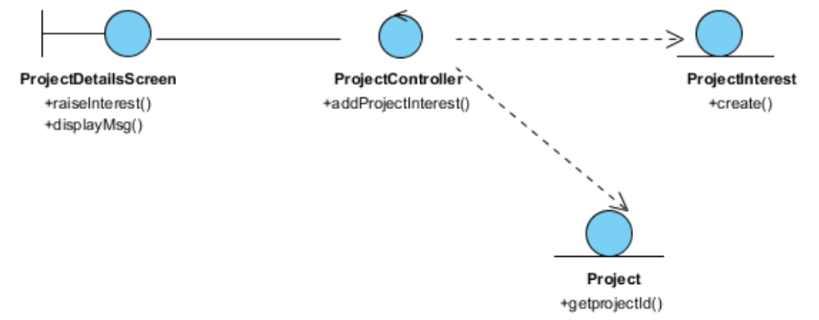

Derived Requirements

ANNEX D Amendment History

This is a record of all amendments made to the Document.
Version | Chapter / Section | Page No | Notes of Amendments or Changes

